From:

We're All Currency Manipulators Now
By David Stockman. Posted On Tuesday, August 6th, 2019
Call it the monetary theatre of the absurd. After all, here is what a determined currency manipulator did between September 2002 and July 2008.
To wit, it pumped about $200 billion of new dollar liabilities into the world financial system, thereby expanding the Fed's balance sheet by 26%. Clearly, global traders and US trading partners didn't welcome that flood of freshly minted fiat currency because during the same period, the traded-weighted dollar exchange rate plunged by 25%.
Moreover, there can be little doubt that the severe slump in the US dollar shown below was deliberate. During much of that period, the Fed conducted an aggressive campaign to
- slash interest rates,
- goose domestic growth and
- perk-up the inflation rate.
The last objective in particular was the brain child of newly appointed Fedhead Ben Bernanke, who falsely warned Greenspan & Co. about the dangers of an imminent "deflation" that never remotely happened.
Needless to say, the impolite word for a policy of suppressing domestic interest rates and goosing inflation is trashing your own currency. All things being equal, foreigners will lighten their dollar holdings and trade the dollar down when authorities promise to reduce its purchasing power and to push yields lower relative to alternatives abroad.
The truth is, the U.S. Federal Reserve is the all-time champion of currency manipulation, and has been ever since Nixon severed its tie to gold in August 1971.
That's because in a fiat currency world, domestic monetary policy is inherently an exercise in currency manipulation: The effects of Fed policy changes (or those of any other significant central bank) are transmitted instantly into external FX and related global financial markets---once the protective moat of a fixed exchange rate is removed.
The last bolded phrase is the heart of the matter. Under Bretton Woods and preceding gold-based fixed exchange rate regimes, domestic monetary policy did not change the FX value of a currency, either immediately or over time.
It did have external effects, of course, but those were transmitted through the inflow/outflow of reserve assets/gold depending upon whether domestic monetary policy was causing the banking system and domestic credit to contract or expand.
Under the gold standard (when it was actually being observed during peacetime and convertibility was not suspended), therefore, countries could stupidly try to slash interest rates in order to goose domestic credit and inflation in a futile effort to kick start prosperity, but the negative feedback loop was swift and painful: To wit, the resulting accelerating outflow of gold or other reserve assets, drained domestic banking systems of high powered money and sent interest rates boomeranging right back higher, which in turn caused loans to become scarcer or even existing credits to be liquidated and economic activity to slow.
Stated differently, under the gold standard you didn't need any nincompoop Secretary of the Treasury like Steve Mnuchin or a statist madman in the Oval Office like the Donald to stop "currency manipulators". The international gold market did the job with unblinking efficiency and on a level playing field. That's because at the end of the day, all gold-backed currencies which maintained their fixed exchange rates were effectively the same money---just printed in different colors and bedecked with the images of different sovereigns, living and dead.
To be sure, like any other human institution, the modern international gold standard did not work perfectly. During the 1920s, for example, as the major countries struggled to resume convertibility after the World War 1 hiatus, central bankers---led the Bank of England and the Fed---conspired to defeat or override market forces, and ultimately paved the way for the system crash when England suspended convertibility in September 1931.
Likewise, Bretton Woods was inferior to the 1920's gold exchange standard and the latter was itself inferior to the gold bullion and gold coin systems of the pre-war era.
That's because Bretton Woods relegated the disciplinary arm of the free market in gold to a sideshow, which US, IMF and other national financial officials could override when push came to shove. That was especially the case for the US currency because the dollar had been self-anointed as a "reserve currency"(i.e. gold substitute) at the 1944 wartime conference which created the Bretton Woods system.
Still, you couldn't wake up some arbitrary morning and find that the Yuan FX rate had suddenly pierced the so-called 7.oo/USD line in the sand as happened Sunday night, nor would there have been an instantaneous threat of punishment via the CM branding iron that the Donald wielded within a matter of hours.
Instead, changes to parities against the dollar/gold anchor to the system came from international negotiations, which almost always took considerable time and usually leaked long before the event. Even then, the result was always described as a parity reset, not a unilateral exercise in nefarious "currency manipulation".
Needless to say, that was then. But since the abomination of Camp David in August 1971, exchange rates have been in constant, sometimes fevered motion on a 24/7 basis, and have given rise to a $5 trillion per day (yes, with a "T") trading market that functions mainly as a forum to discount the impending actions of dirty-floating central banks.
Accordingly, "currency manipulation" is endemic, chronic and entirely subjective. It exists only in the eye-of-the-beholder at random times and FX rates when domestic politicians are looking for the proverbial foreign scapegoat. And since that is the Donald modus operandi, the phantom of currency manipulations has suddenly come back front and center to the financial narrative.
As a purely practical matter, therefore, the US statutes---the 1988 Act and the 2015 Act----which authorize the Treasury to stamp a red letter CM (currency manipulator) on the forehead of any offending foreign country are an exercise in absurdity and an invitation to destructive mercantilist interference with global commerce.
Indeed, the statute used yesterday afternoon (the 1988 act) leaves little to the imagination. It authorizes the Secretary of the Treasury to brand foreigners as bad guy CMs whenever he can read the minds of foreign central bankers and financial officials and determine that their exchange rates had fluctuated from one arbitrary point to the next not for valid economic reasons, which are plenary in a world of dirty floats, but because their motivation in his judgment was untoward.
That is, currency manipulation is a sin of intent, not a measureable quantitative infraction:
Under Section 3004 of the Act, the Secretary must "consider whether countries manipulate the rate of exchange between their currency and the United States dollar for purposes of preventing effective balance of payments adjustment or gaining unfair competitive advantage in international trade.”
Now exactly how would a dunderhead like Steve Mnuchin know the difference between permitted and unacceptable FX fluctuations in the current instance? Or for that matter, how could even alleged geniuses who previously occupied the post---Larry Summers, Bob Rubin, Hank Paulson etc.--have known the difference, either?
In fact, the 1988 Act was the product of sheer legislative stupidity by a Congress that still didn't get the joke 17 years after Nixon had shit-canned gold-based money and the fixed exchange rate regime internationally that it had enabled in rough but serviceable form.
After August 1971 the truth of the matter was, to paraphrase Tricky Dick's famous line when he embraced Keynesian fiscal policy, "we are all currency manipulators now".
Accordingly, even the Keynesians and statist political apparatchik's who occupied the Secretary of Treasury office and other top economic positions at least understood that brandishing the CM branding iron would be an exercise in pure political caprice and a slippery slope at that.
In the face of the chart below, why would not the US have been the first in line for the hot CM branding iron?
The sheer nonsense of the currency manipulator notion is perhaps the reason why hundreds of millions have been wasted by US Treasury investigations of "currency manipulators", most especially China, over the years---without making a positive finding in more than two decades.
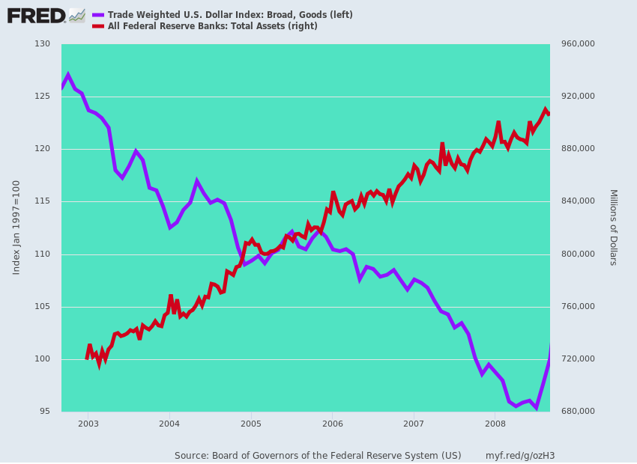
In the great scheme of things, therefore, there is only one reason for last night's break from the wink and nod non-enforcement regime of the last 25 years. Namely, that the great trade-czar-in-chief got pissed off because he thought (rightly) that the Chinese allowed the Yen to drop a few ticks Sunday night (our time) in response to his 10% tariff attack last week. As Bloomberg noted:
Trump and those around him have been frustrated by China’s response to his tariffs. By allowing its currency to depreciate through the symbolic 7-per-dollar mark on Monday, policy makers in China preemptively helped offset the cost of a 10% tariff he plans impose on some $300 billion in Chinese imports on Sept. 1.
The dead give-away is right in the first sentence of the announcement, wherein the water-boy who serves as Secretary of the Treasury essentially said, "The Donald made me do it!"
Secretary Mnuchin, under the auspices of President Trump, has today determined that China is a Currency Manipulator.
As a result of this determination, Secretary Mnuchin will engage with the International Monetary Fund to eliminate the unfair competitive advantage created by China’s latest actions.
Folks, we have been reading the flotsam and jetsam emitted by Cabinet Departments for decades but are hard-pressed to recall the phrase "under the auspices of President...."
In fact, last night's currency manipulator charge against Beijing was just another tit-for-tat escalation of the Donald's hugely misguided Trade Wars on China. It will simply provide an excuse for new sanctions against American businesses which may want to import goods from China; or for "punishment" of China in the form of or an even higher rate of tariff than the 10% already promised for September 1 on shoes, shirts, suitcases, toys, tricycles, laptops and iPhones etc.
In fact, the rubbery 1988 statute dusted off by the Trump Administration is much like the virtually open-ended 1962 and 1974 trade acts, which the Donald has mightily abused. So doing, he has essentially appointed himself as Global Trade Czar and the dictator of global supply chains (i.e. for some reason he wants importers to source in Vietnam rather than China although the former is every bit as much a (communist) statist abuser of so-called free trade as is China).
Now the Orange Swan will be conducting his Trade Wars with yet a third open-ended authority (and an utterly unconstitutional one in the days before FDR's New Deal finally overrode the Schechter decision). And it will potentially permit private companies to sue for protective tariffs or other compensation upon the claim they have been harmed by China's "currency manipulation".
If you think the Wall Street crybabies are bad, therefore, wait until the Chamber of Commerce and the NAM mobilize their K-street lobbies to bring section 3 cases under the 1988 Act. Economics based global trade will be even further upended by more arbitrary political interventions and distortions.
Needless to say, this latest blast is just Trumpian-style protectionism in another form. That's because there is virtually zero case that China has "manipulated" its fiat currency over the years any more than Japan, the ECB, the US or all the other small fry in between; and no case at all that during the last few days or weeks that its practices have somehow turned for the worse, and now merit an unprecedented CM designation.
The joke actually runs in the other direction. In the current context, China is being labeled a currency manipulator for not manipulating its currency enough!
That's right. Ever since the Donald launched a new round of the Trade War in May by walking away from the then pending deal and escalating existing tariffs on $200 billion of Chinese goods to 25%, the Chinese have been intervening in the currency markets to prop up the Yuan and prevent it from sinking further in the face of the US tariff.
Indeed, virtually every trader on the global FX marts knows Trump's Trade War will drive business out of China, crush profits of those Chinese suppliers who choose to eat the tariffs and generally undermine the stability and growth capacity of the Red Ponzi.
So they intensified their selling of off-shore Yuan, prompting the central planners in Beijing to chose to prop up the FX rate by buying Yuan and selling dollars. And that's the very opposite of letting the currency slide in order to off-set the Donald's malicious tariffs. It was actually helping to make them effective!
Of course, when Beijing was hit, apparently without warning, by the Donald's 10% tariff hissy fit against another $300 billion of Chinese imports after his negotiators returned from Shanghai empty-handed last Thursday, they apparently concluded enough is enough.
In fact, they got all Uncle Milton Friedmanish and let the free market rule for a few hours Monday, which promptly caused the off-shore Yuan to punch through the 7.00 line like a hot knife through butter.
So in the Bizarro world of Donald Trump even a one-day break-out of the free market on China's FX exchanges could not be tolerated. Within hours the pip on the 5th floor of the Treasury Building was squeaking per the above quote that the Donald made him do it.
So to repeat: In today's real world of fiat currencies, massive monetization of public and private debts and other securities by the central banks and systematic, planet-wide dirty floating, every nation manipulates its currency; and such manipulation can be shown to be "good" or "bad" under the Donald's primitive trade accounts scoring system (i.e. it's good if other countries strengthen their FX and bad if they weaken it) depending upon exactly what starting and ending point you arbitrarily choose.

The chart below illustrates this point with respect to China, but you could make the same arguments based on any other currency pair you might pick.
Needless to say, the real Chinese FX "manipulation," if you want to call it that, happened years ago as demonstrated by the modern history of the China/U.S. dollar exchange rate since 1989.
First and foremost, if you can spot the purportedly blatant "manipulation" of the last few days or months that led to last night's CM declaration, you have better eyes than even the proverbial boy who dropped his bubble gum in the chicken coop and was determined to find it.
You can't find it in the last few weeks or months because the modest weakening and strengthening of the Yuan during that time frame doesn't amount to diddly squat in the context of the last three decades.
As shown in the graph, the truly blatant manipulation, at least in theory, occurred in the early 1990s when China embarked upon Mr. Deng's export strategy and sharply devalued the Yuan from 3.71 to the dollar to high of 8.76/USD after the maxi-devaluation in September 1993 (vertical rise).
That amounted to nearly a 60% reduction in the exchange value of the Yuan, most of it on the day of the maxi-devaluation. Yet even that is not totally clear cut because the exchange rate of 1989 represented essentially the arbitrary state posting of an autarkic Maoist economy that had only tiny interaction with world markets in goods and finance. Two-way trade with the US that year, in fact, amounted to only $4 billion.
In any event, once the new mercantilist/export regime of China stabilized its FX at 8.32/USD in June 1995, the Beijing "manipulators" kept the FX rate absolutely stable at that level for an entire decade through June 2005. You could set you watch by it.
Of course, that was "manipulation" just the same because during that same period China's trade surplus soared and its FX reserves surged by 11X from $65 billion in mid-1995 to $730 billion in June 2005.
In a fiat currency world, that's "manipulation" because in the face of an honest, Milton Friedman style free market float, China's exchange rate would have strengthened dramatically, not remained flat as a board.
So Beijing's surging FX reserves were the smoking gun. If Washington really wanted to be in the absurd business of the pot calling the kettle black, it should have fired up the branding iron and struck it to China's forehead two decades ago.
But Washington had other reasons for keeping quiet. China's cheap currency served to tide over the American middle class with cheap imports which they couldn't have afforded from domestic producers--even if it came a the cost of slowly shipping much of America's industrial base off-shore.
Then, of course, Beijing's policy began to move in the opposite direction. During the nine year stretch between June 2005 and June 2014, the exchange value of the Yuan strengthened to 6.06/USD. That amounted to nearly a 40% appreciation of the Yuan.
But, alas, those nefarious Chicoms were still manipulating their currency. The smoking gun proof is that China's FX reserve pile kept growing and growing until it reach the absolutely freakish level (compared to all of world history) of $4.1 trillion in May 2014. That further $3.3 trillion growth of FX reserves between 2005 and 2014 was the fruits of currency market intervention designed to prop-up the dollar and weaken the Yuan. Full stop.
Finally, in the five years since 2014, Beijing has essentially been on "good" behavior, as demonstrated by the fact that its FX reserves have declined to about $3.1 trillion. In effect, it dumped dollars and other FX reserves in order to prop-up (strengthen) the Yuan, not cap (weaken) it as between 1993 and 2014; and it did so for its own understandable reasons.
To wit, its newly enabled billionaires, lesser entrepreneurs and globalized companies could see that China's economy does not walk on economic water and is not something new under the sun. It is a monumental debt-ridden Ponzi that will one day collapse upon itself---so the smart people in China wanted to get their wealth out before it was too late.
Beijing thus spent nearly $1 trillion of FX reserve over that five year period fighting, ironically, the market-driven weakening of its currency!
Even then, it was only partially successful. Notwithstanding massive Yuan purchases between June 2014 and the Donald's election, China's FX rate weakened substantially to 6.94/USD in December 2016. In the whacky world of currency manipulation, that amounted to a 13% depreciation.
As the Keynesian might say, very bad, if they were advising the US government, and very good if they were advising Beijing.
In any event, when the Donald was sworn the oath, Beijing embarked up an even more determined currency support operation, and did get the FX rate back to 6.28/USD by April 16, 2o18.
That amounted to a 10% appreciation of the Yuan, but from the Donald's corner, no cigar!
That is exactly the point from which he launched his explicit Trade War with China, and the rest is (unfortunate) history.
Oh, yes, and upon China's FX fixing last night at 6.97/USD, its exchange rate stood almost exactly where it was (6.94/USD) in the days after the Donald's improbable victory. Even in Washington, a 0.035% difference is close enough to equal for government purposes.
As we said, currency manipulation is purely in the eyes of the beholder.
And the beholder in the Oval Office absolutely cannot see straight.
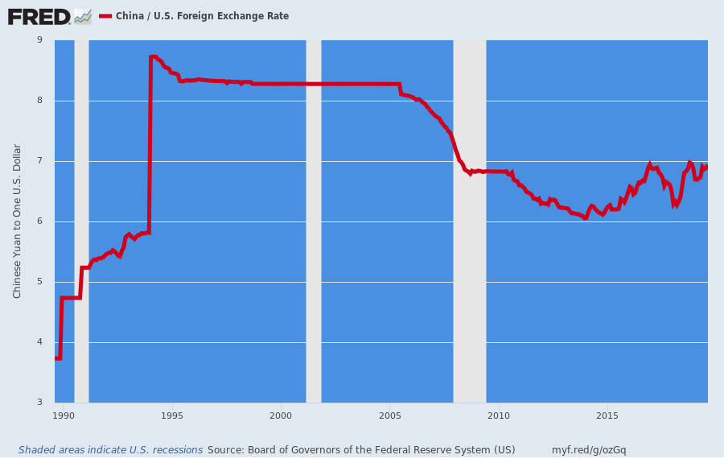
For want of doubt, the actual 30 year history of China's FX reserves and exchange rate is shown below.
The only thing it really proves is that fiat currencies are always and everywhere manipulated, and that the Fed is driving the entire convoy of global central bankers who do it.

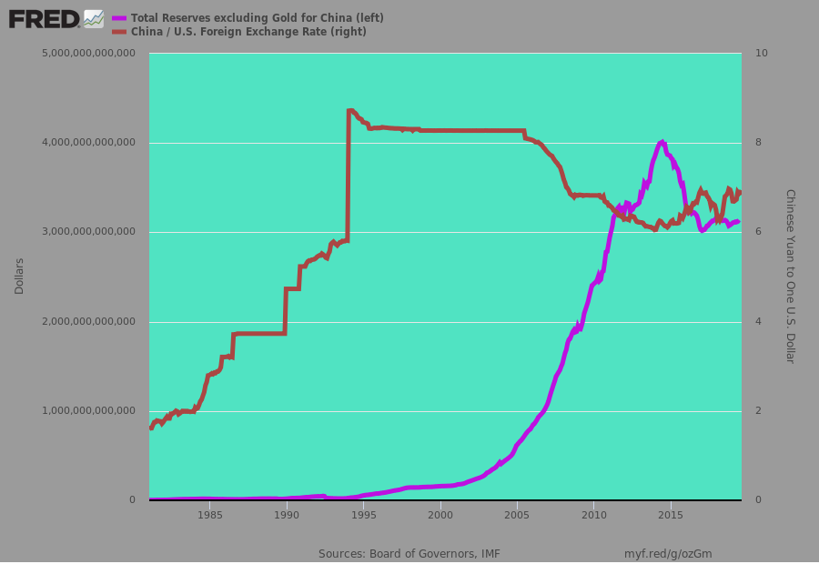
Indeed, as the great Gary Kaltbaum observed this AM:
Lael Brainard, a fedhead who happens to chair the financial stability committee at the fed has already stated they are watching markets. The people that were one of the main causes of 08 and have enabled the massive debt and leverage we are seeing now have a committee on financial stability. Fill in the joke.
If we deem China a currency manipulator, what about the other 729 rate cuts in the past 10 years? What about our central bank taking rates down to 0% for 8 years and printing $4-5 trillion?
China is indeed a currency manipulator. So is everyone else.

